Same sex relationships are illegal in over 70 countries

11 nations have the death penalty for same sex relationships

This has to stop
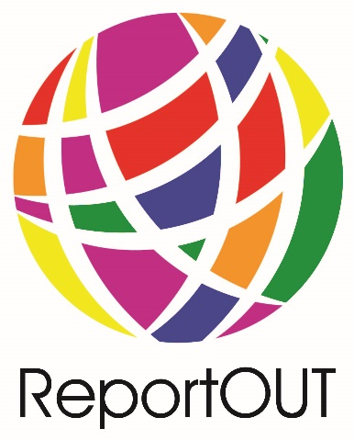
#RideForRights
#ReportOUT

