Volunteer Role Descriptor

Role | Media and Communications Officer
Reporting to | Craig Millar (Media and Communications Trustee)
Average hours | 16 hours per month (not including additional volunteer team meetings)  Though please note that we are flexible around your life, work and childcare.

Volunteering at ReportOUT:
Reliable, well-trained and passionate volunteers are vital to the work of ReportOUT and to our three-year Strategic Plan (2019-2022). Our volunteers give more than their time and energy, they are a vital part of our organisation and so we invest heavily in volunteer support, training and development. We offer a professionalised volunteering experience at ReportOUT and our roles and your responsibilities given, will reflect this.

We seek highly skilled, flexible, reliable and experienced individuals to join us. Due to organisational demand we are after specific skills and abilities in our volunteering roles. Whilst all of our volunteer roles have clear roles as set out in this role descriptor, your role sometimes demands more and so we need people who are flexible and 'can do' in their approach.

Our volunteering process:
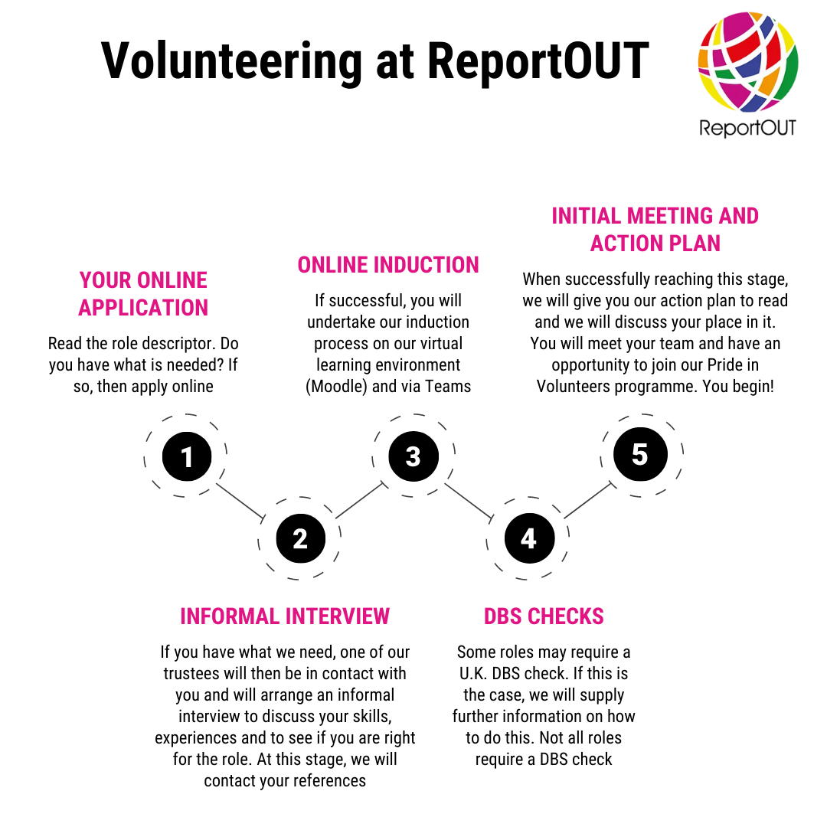

What does this role do?
We are always looking for volunteers to support with delivering our communications, and no matter what your specialism, we will have a role for you. We are looking for those who can get started straight away with mini-projects and to support our largely digital communications approach and get started quickly.

All of our Media and Communications Officers cover all aspects of the report out external relations activities. The Media and Communications Team support with the transformation of complex global issues and highly emotional stories into a narrative that can be understood by a wide range of audiences. All Communications and Media Officers will:

- support with the transformation of complex and emotionally challenging stories into a consistent and audience appropriate narrative for the charity.
- keep our website vibrant and up-to-date;
- ensure that all our web content is distributed through other digital channels in a timely and consistent way;
- work with all volunteers to provide a consistency in approach to the way we communicate, including supporting with the creation of key message libraries and glossaries;
- lead on communications and media projects that aim to maximise the reach of the charity and the global issues we uncover;
- maximise internal communications through supporting with the creation of an intranet;
- write copy for any on or offline platform.

In addition, each volunteer will be aligned with another function of the ReportOUT family to ensure that the flow of information from and to other volunteers and teams is smooth and helps us maximise coverage of every aspect of the charity.

Within our Media and Communications Team, we have a number of specialisms depending on your skills and experience or your interests. The area of focus will be established when we have an interview and induction with you. Areas of focus that we require as an organisation are:

Social and digital content
- Keeping our social media channels up to date with relevant content that drives attendance and awareness of our marketing campaign messages. Working with other teams you will make sure that our activities are well promoted.

Digital editorial
- Ensure that the organisation is keeping in touch with its stakeholders through the website and regular newsletter features. Will collect news and stories from internal and external sources, and position these to the charity's vision.

Digital growth
- Grow the digital penetration through maintaining an overview of our own channels and maximising the use of partnerships with other aligned sites. Driving engagement with other channels, we will ensure that our messages are aligned with those of appropriate partners and delivered with integrity.

PR and media relations
- To lead on the researching, development and the roll out of strategical positioned PR. Developing well written and multi-channel relevant pieces that escalate the charity, with the support of academic writing.

What do we expect from you?
- a very pro-active ‘get up and go’ attitude to this role;
- a commitment to learning about the global human rights of sexual and gender minorities (training will be given about this);
- a willingness to reach out to global sexual and gender minorities when needed;
- a willingness to reach out to professionals in the United Kingdom;
- commitment to attend individual team meetings;
- commitment to attend our monthly volunteer team meetings;
- commitment to work with other volunteer teams where there is crossover in roles;
- to read and abide by relevant policies;
- to take part in a volunteer supervision with your lead trustee every 3 months;
- to use our internal and external communication systems when needed and to keep abreast of them often;
- strong IT skills so you can operate Microsoft systems and learn other systems with ease;
- to show excellent levels of punctuality and attendance at meetings and events;
- to be able to volunteer unsupervised, using your own initiative;
- to demonstrate excellent attention to detail;
- to be able to work effectively as part of a team;
- to be able to work effectively to conflicting deadlines;
- to show a strong commitment to equality and diversity principles, data protection laws and confidentiality guidelines;
- to help us to achieve our goals in our annual action plan;
- to be a positive advocate for ReportOUT publicly.

What skills, qualifications and experiences do you need for this role?
- good communication (written and verbal) skills;
- an understanding writing for digital marketing tools, such as social media, website and blogs;
- good digital skills across a range of platforms and systems;
- ability to spot a story that would be of interest to a wide range of audiences.
- working in or seeking to work in a marketing, PR, events, design or communications role;
- a student or graduate who wants to develop real world skills and experience but have studied or currently enrolled on a relevant degree level qualification. If you have not yet reached your career goals yet, we are sure that volunteering with ReportOUT will help you on that journey;
- a marketing or communications professional who wants to support the charity and its message;
- confidence in dealing with members of the public and professionals;
- excellent levels of written and spoken English are essential;
- strong digital skills and adopters of a digital first approach;
- an ability to speak any foreign languages is desirable but not essential.

